**P7. Pointer Arithmetic**

**Benjamín Valdez Rodríguez**

**A00822027**

**Código**

//

// main.c

// P7 Pointer Arithmetic

//

// Created by Benjamin Valdez on 2/21/20.

//

#include <stdio.h>

**void** changeString(**char** *address) {

**int** i = 0;

**while** (*(address + i) != '\0') {

**switch** (*(address + i)) {

**case** 'a':

*(address + i) = '4';

**break**;

**case** 'e':

*(address + i) = '3';

**break**;

**case** 'i':

*(address + i) = '1';

**break**;

**case** 'o':

*(address + i) = '0';

**break**;

**case** 'u':

*(address + i) = '2';

**break**;

**default**:

**break**;

}

i++;

}

printf("%s", address);

printf("\n");

}

**int** main(**int** argc, **const** **char** * argv[]) {

**char** input[60];

**char** *ptr;

printf("Give me a string: ");

fgets(input, **sizeof**(input), stdin);

ptr = &input[0];

changeString(ptr);

**return** 0;

}

**Caso de Prueba 1**

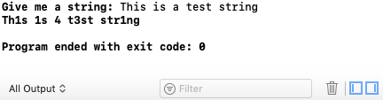

**Caso de Prueba 2**

